HNY5180TWQD6 MASTER CLEANER TRUCK
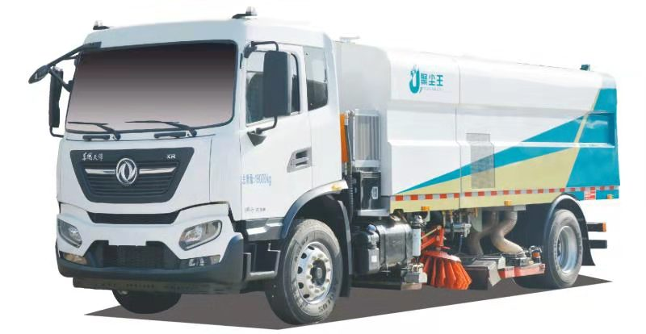
【Main parameter】
Brand name | JUCHENWANG | Batch No. | 324
Product name | Master cleaner for pollution | Product No. | ZPGSN69X012
GVW(Kg) | 18000 | Passengers | 3
Rated weight(Kg) | 5420 | Overall dim.(mm) | 8635×2500×3000
Curb weight(Kg) | 12450
Approach/departure angle(°) | 17/13 | Front/rear suspension(mm) | 1400/1935
Axle No. | 2 | Wheelbase(mm) | 5300
Axle load(Kg) | 6500/11500 | Max. speed(Km/h) | 89
【Chassis parameter】
Chassis model | DFH1180EX8 | Chassis name | Cargo chassis
Brand name | Dongfeng | Manufacturer | Dongfeng Motors
Overall dim.(mm) | 9090×2470×3090 | Tyre No. | 6
Approach/departure angle(°) | 17/13 | Tyre model | 275/80R22.5 18PR
Steel spring no. | 8/10+8 | Front tread(mm) | 1920
Fuel type | Diesel | Rear tread(mm) | 1860
Emission standard | Euro VI
Engine Type | Engine Manufacturer | Displacement(ml) | Power(Kw)
D6.7NS6B230 | Dongfeng Cummins | 6700 | 169
Other | U type rear waste treatment，DT0690 Dongfeng 6 shift gearbox，Front axle:4.5T，Rear axle:10T，160L fuel tank，Central lock and electric window in cab.
【Attachment parameter】
Secondary engine | Cummins QSB5.6-C160-30 | Power (Kw) | 119
Min. operation speed (Km/h) | 3.9 | Clean width(m) | 3.6
Max. operation speed (Km/h) | 20 | Cleaning rate(％) | 99%
Max. capacity of operation(㎡/h) | 64000 | Volume of clean water tank (L) | 8300
Unload angle(°) | 47 | Volume of garbage tank (L) | 5000
【other function】
High pressure water pump: Italy VXX-B 130/220R ram pump，stainless pump head，proper rate of flow; High pressure，allowed max. Pressure: 22MPa
Fan machine: FCFII-6a-C-R90°(High pressure centrifugal fan for cleaning truck，High efficient，large air volume
Equip with steel roll brush, plate brush, high pressure flushing system and vacuum sucking system. Clean up highly the asphalt pavement to remove dirt in the seepage hole and recover the cleaning surface.
Equip with smart PLC control panel in the cab. One touch of smart operation: 4 model for automatic operation”Full washing and sweeping，Left /Right washing and sweeping, Quick wet sucking”It’s easy and safe to operate.
Garbage tank is stainless steel, which has the dumping and self-cleaning equipment. Touch panel shows the water level of rear window level.
Wide range of adoption: steel factory, cement plants, smelters, thermal power plants, port terminals, highways, mining roads, airport runways, urban roads etc.
The side sucker with ability of anti-collision and avoiding automatic reset, it can close the road without being damaged.
During operation of the garbage tank sewage level up to the specified height, drainage and then work until the tank filled with garbage.
Garbage tank with self-cleaning device, self-cleaning device can help discharge garbage and cleaning inner tank.
Equip with safety warning system, considering the use of traffic, passenger flow and operation at night, set up safety warning lights to ensure to operate in different environments.
Four cameras around the front and back of the vehicle device for easy operation and auxiliary operation

